Create Local Database

Firstly, download SQL Server Management Studio (SSMS) if you do not have it already, the link at the time of documentation is - <https://docs.microsoft.com/en-us/sql/ssms/download-sql-server-management-studio-ssms?view=sql-server-ver15>.

Open SSMS, you should be prompted with a Connect to Database Engine.

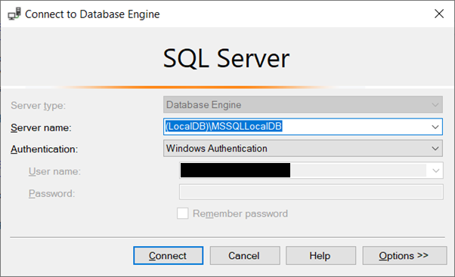

Type in your local db information in the server name input, mine was (LocalDB)\MSSQLLocalDB.

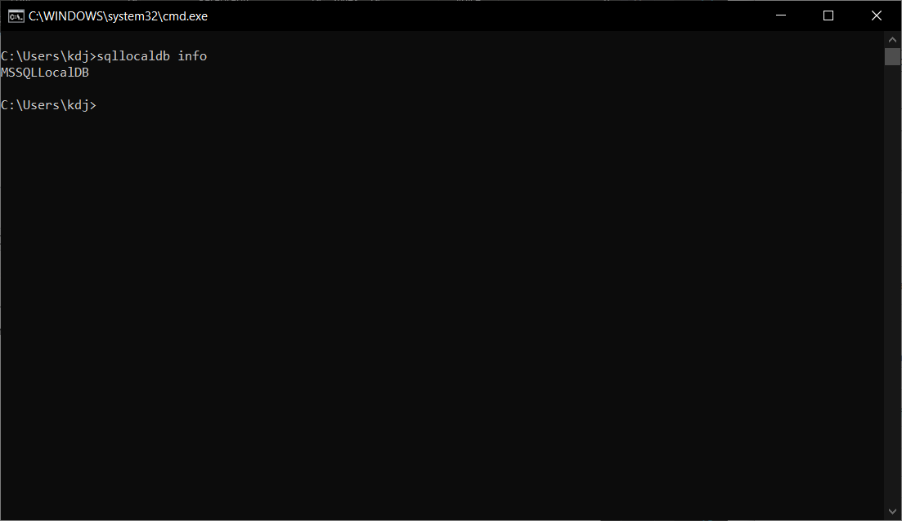

To find your local db information open command prompt (hold down the Windows Key and Press R on your keyboard then type cmd) and enter sqllocaldb info.

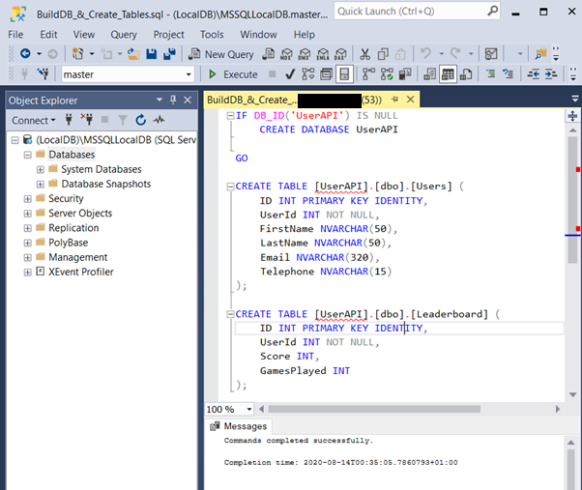

After clicking connect you should be connected to your local database. Now run the BuildDB_&_Create_Tables.sql script onto your master database by clicking Execute button.

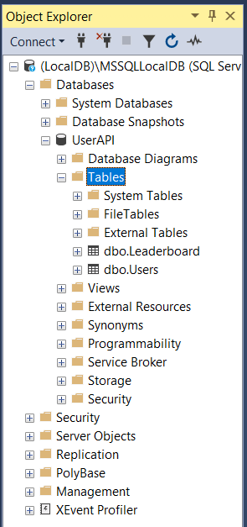

Right click and refresh your local db connection to view the new database and tables.

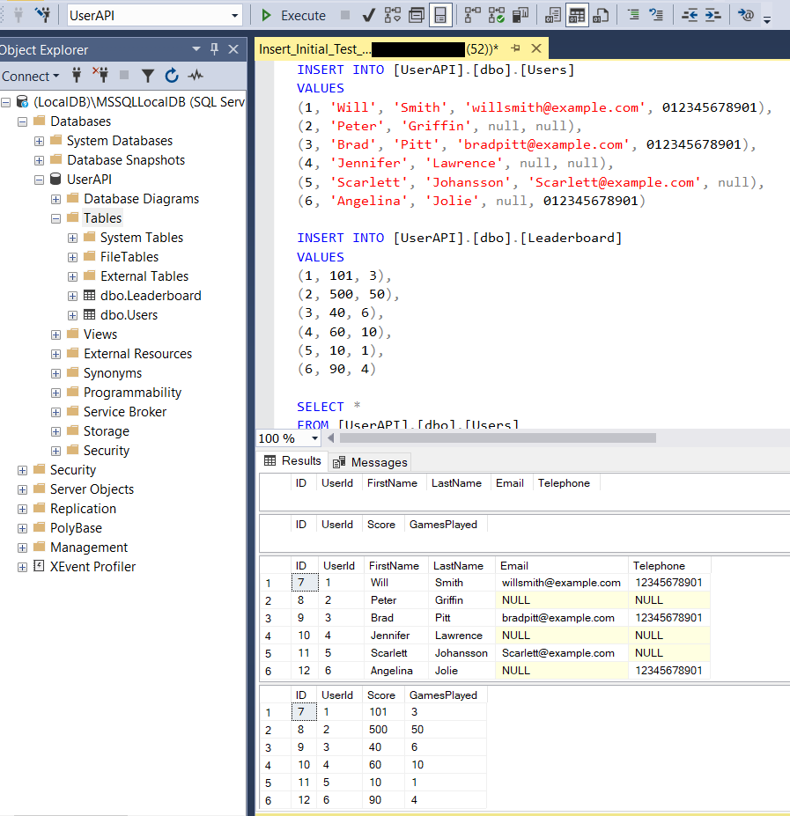

Choose the UserAPI database from the dropdown and run the Insert_Initial_Test_Data.sql script.

Now you are ready to use/run the project.